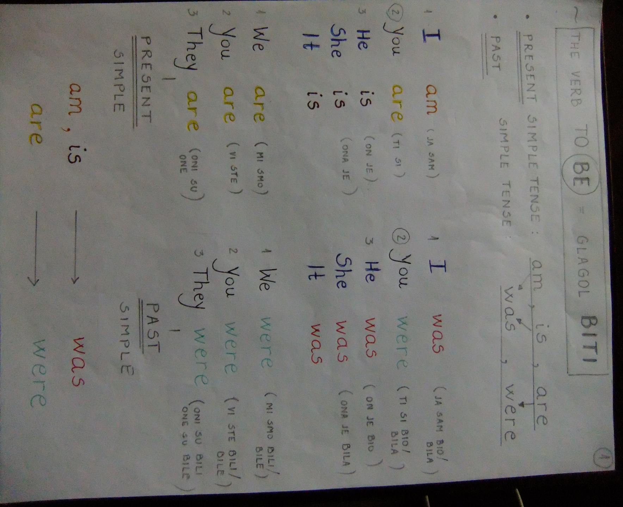

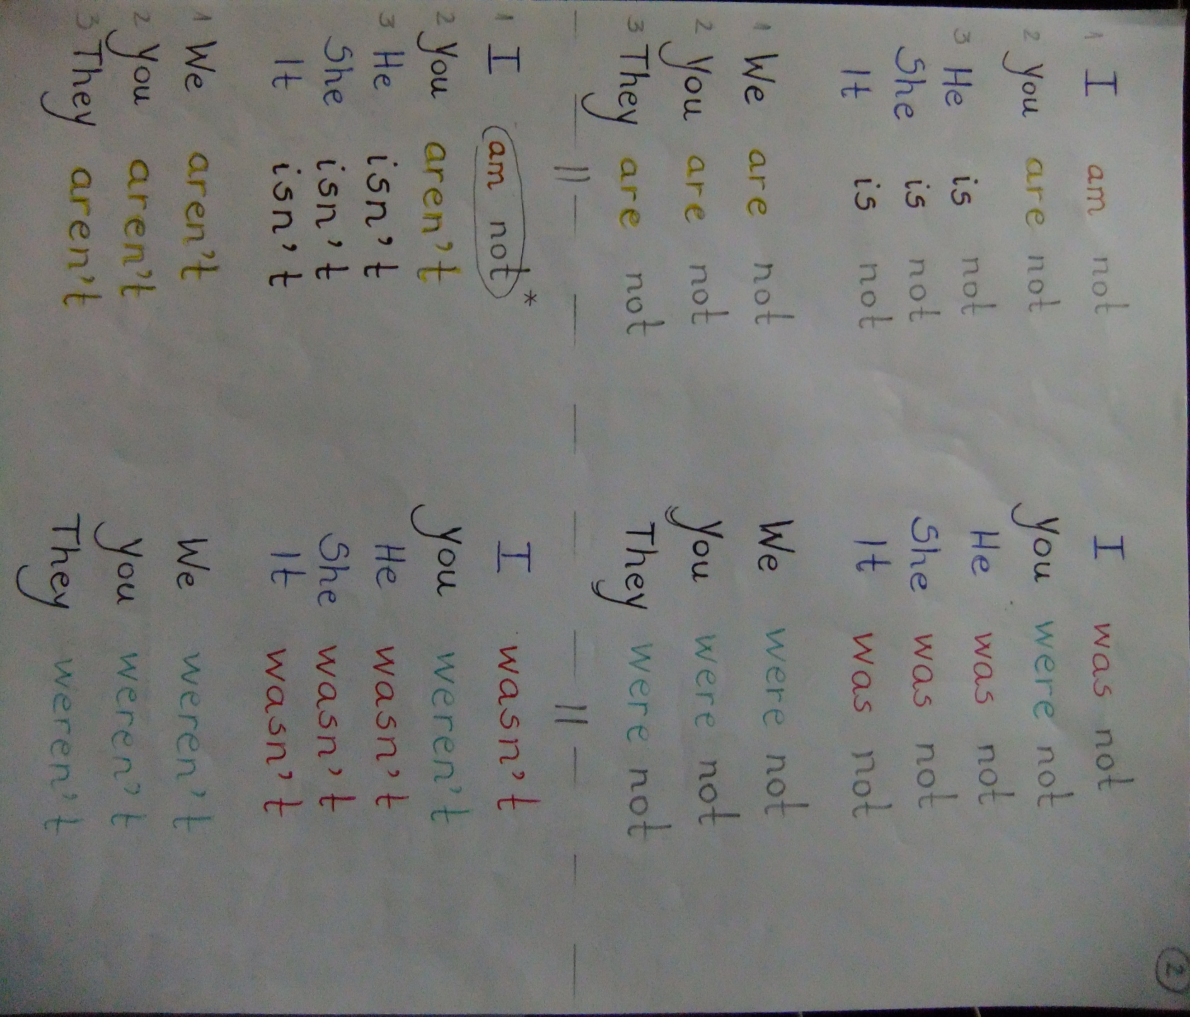

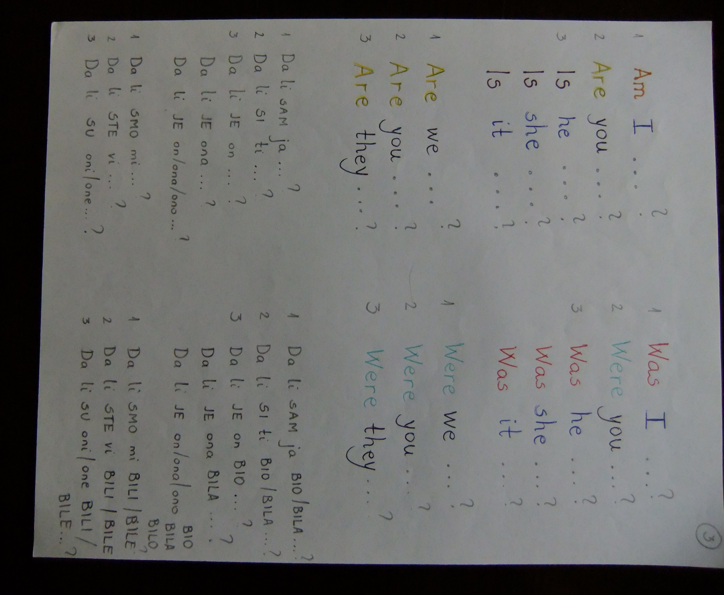

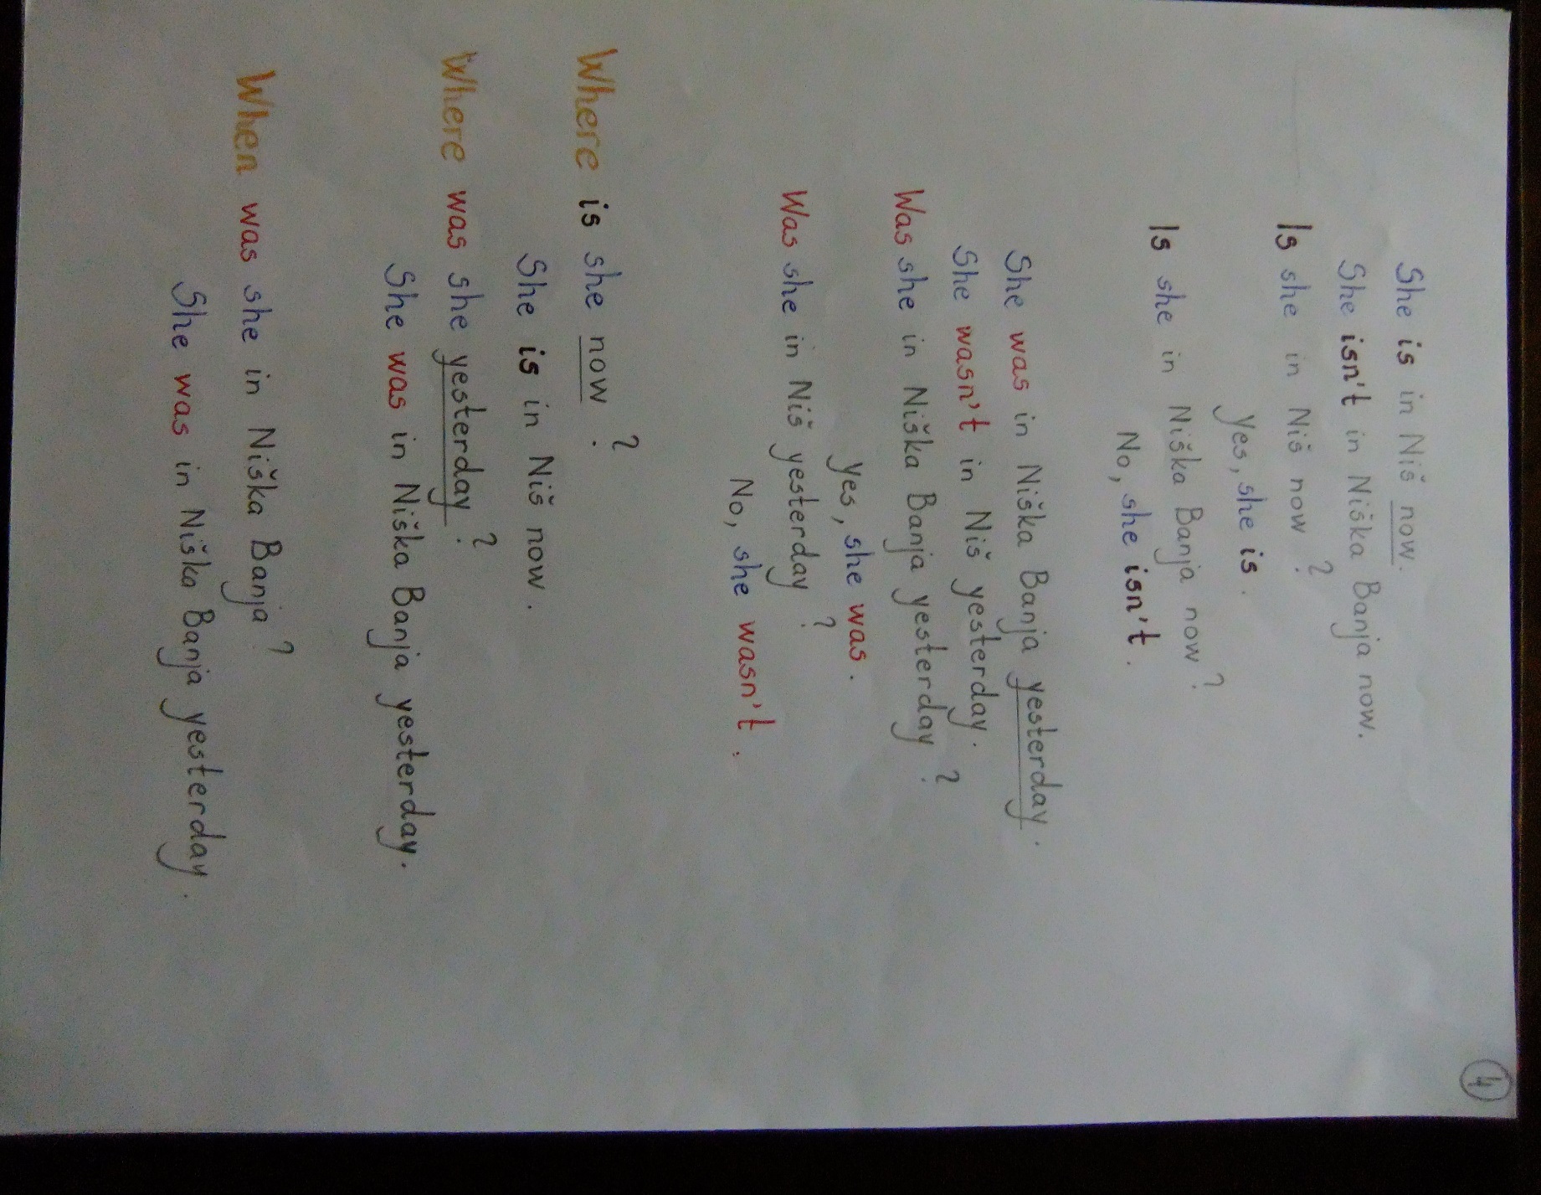

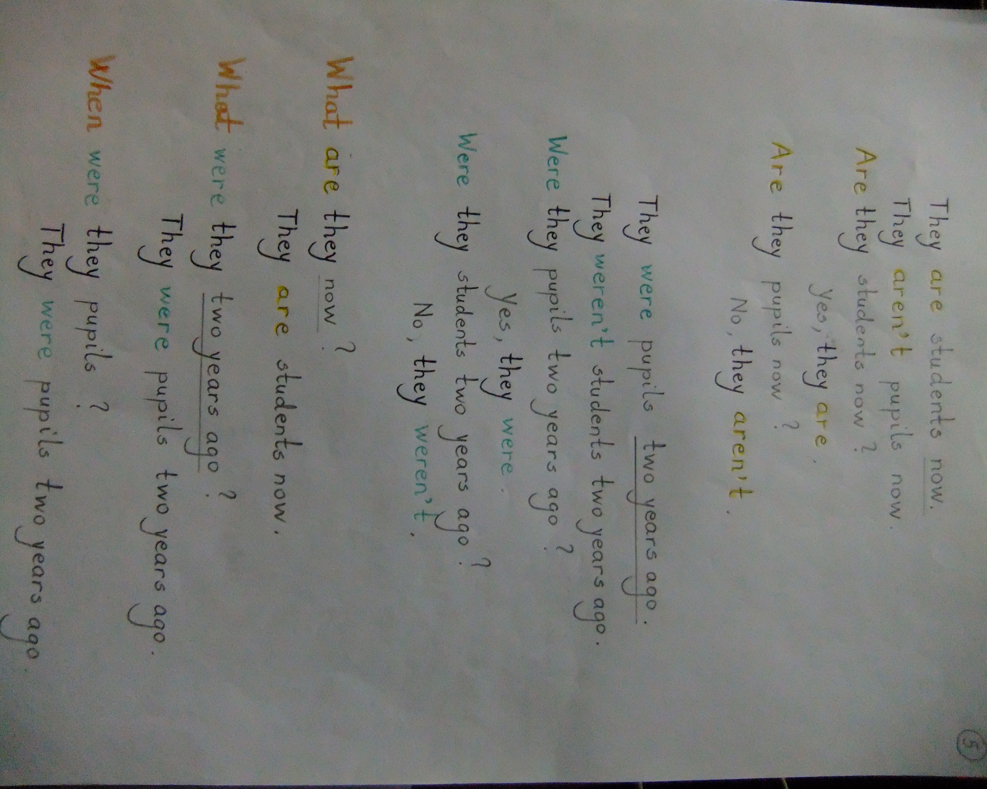

TЕМА 2: PAST ACTIVITIES (АКТИВНОСТИ/ДЕШАВАЊА У ПРОШЛОСТИ)

Let’s practice grammar! (Вежбајмо граматику!)

- Write was or were:
* Након што завршите, можете да проверите да ли сте све тачно урадили.
Решења се налазе у доњем делу ове странице.

- I __________ tired yesterday.
- You __________ sad yesterday.
- We __________ happy yesterday.
- They __________ hungry last night.
- Our friends __________ thirsty last night.
- My sister __________ very sleepy last night.
- Her brother __________ bored last night.
- It __________ hot last week.
- The hotel room __________ cold last weekend.
- The children __________ scared at Halloween.

- Write the sentences from ex. 1 in the negative and the interrogative (= question) form.
(Напишите реченице из вежбања бр. 1 у одречном и упитном облику.)

- Write 5 sentences of your own using was, wasn’t, were or weren’t.
(Напишите 5 реченицa у којима ћете употребити was, wasn’t, were или weren’t. )

(Решења:
1. а) was b) were c) were d) were e) were f) was g) was h) was
i) was j) were)

